**noSQL Database Attachment**

Top of Form

 A NoSQL (originally referring to "non SQL" or "non relational") database provides a mechanism for storage and retrieval of data that is modeled in means other than the tabular relations used in relational databases (Wiki). It is existed since late 1960. NoSQL database has variety of types based on data model. Mainly are document, key-value, wide-column, and graph. Its definition arises a common misconception that noSQL databases don't store relational data well. noSQL database can store relational data, just they store it differently that a rational databases. The huge volume of unstructured data generated through social media, mobility and cloud challenging traditional RDBMS(Rational Database Management System) to create innovative queries. noSQL has created confidence and opportunities for data collection, analysis and management.  noSQL is giving a good competition to traditional RDBMS. Its popularity increased in the first decade of 21st century. 

When comparing with SQL databases, modeling relationship data in noSQL database is easier, because related data doesn't have to split between tables. noSQL database are document based which doesn't have standard definitions like key-value pair, graph databases or wide-column data categories. This makes them ideal to handle unstructured data. SQL databases are vertically scalable whereas noSQL are horizontally scalable. RDBMS databases are based on theory to use structured query language, while noSQL queries are based on the collection of documents. noSQL works better with hierarchical data structure but SQL databases are not well fitted for it. As the popularity of cloud computing increasing, developers are using public cloud to store their data and application. noSQL provides capabilities to distribute data across multiple servers and regions to make applications resilient and to intelligently geo-place their data.  

Some highly used SQL databases are Oracle, Microsoft SQL server, IBM DB2, while noSQL databases are MongoDB, Redis, Cassandra.

The advantages of noSQL include:

- High Scalability

- Lower Cost

- Un/semi-structured data

- Distributed Computing

- No complex relationship

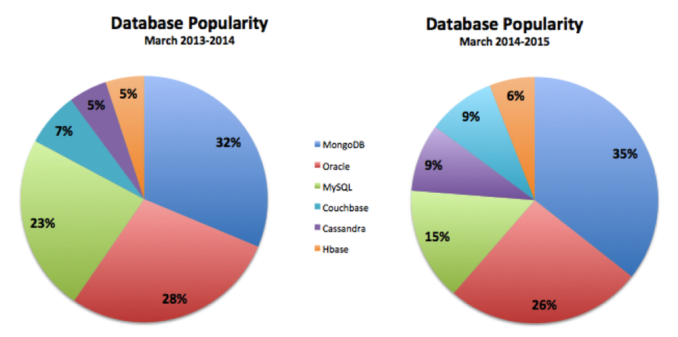

image credit: techrepublic

If you are in need to create an application which will generate lots of reports then RDBMS is a great choice. If you need some analytics functionality in your application then you might see some limitations with traditional RDBMS. That's exactly where noSQL comes in picture. It will help to generate reports b mashed up data for your application consumer.

If you like to try noSQL database [MongoDB Atlas](https://www.mongodb.com/cloud/atlas?tck=nosql-explained) is a great place to start with.

***References:***

<https://www.livemint.com/>

<https://www.mongodb.com/nosql-explained>

<https://en.wikipedia.org/wiki/NoSQL>

Bottom of Form